300986134 Parth Chandgadhiya

# **Lab Assignment 2**

# **Chapter 5 advance challenges**

Create the CATEGORY table and populate it with the given data. Save the changes permanently

Creating the table

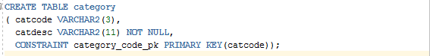





Populating table

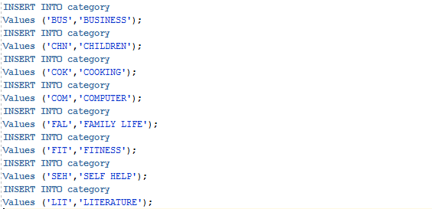

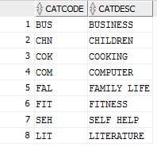

Saving the changes permanently





Add a column to the BOOKS table called Catcode.



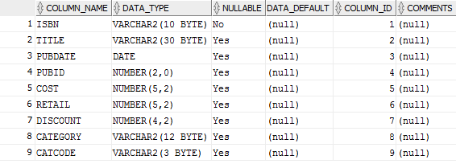

Add a FOREIGN KEY constraint that requires all category codes entered in the BOOKS table to already exist in the CATEGORY table. Set the Catcode values for the existing rows in the BOOKS table, based on each book’s current Category value

Adding Foreign Key

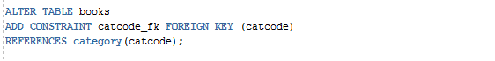



Set the Catcode values for the existing rows in the BOOKS table

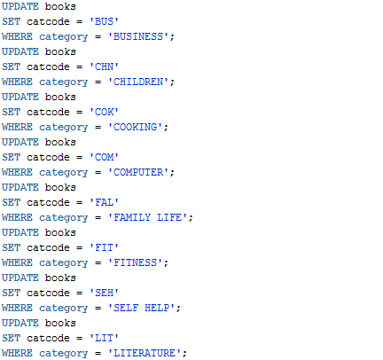

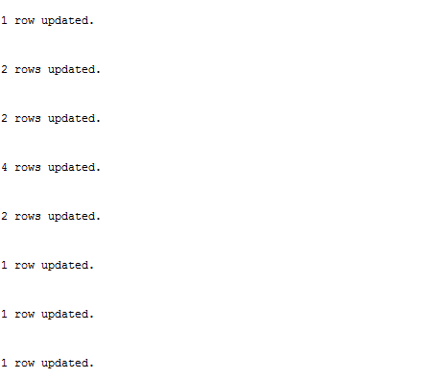

Verify that the correct categories have been assigned in the BOOKS table, and save the changes permanently

Verifying that correct categories have been assigned to books.

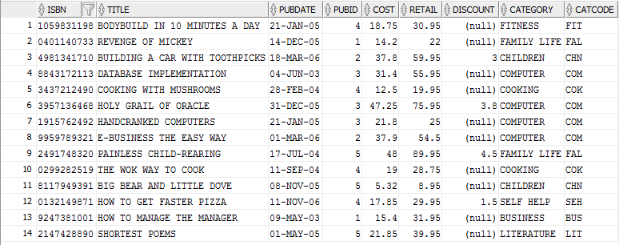

Saving the change permanently





Delete the Category column from the BOOKS table.

Deleting the category column





